Equity Investments

Reading 44 Market Organization and Structure

LOS 44.a

The three main functions of the financial system are to: 1. Allow entities to save, borrow, issue equity capital, manage risks, exchange assets, and utilize information. 2. Determine the return that equates aggregate savings and borrowing. 3. Allocate capital efficiently.

LOS 44.b

Assets and markets can be classified as: Financial assets (e.g., securities, currencies, derivatives) versus real assets (e.g., real estate, equipment). Debt securities versus equity securities. Public securities that trade on exchanges or through dealers versus private securities. Physical derivative contracts (e.g., on grains or metals) versus financial derivative contracts (e.g., on bonds or equity indexes). Spot versus future delivery markets. Primary markets (issuance of new securities) versus secondary markets (trading of previously issued securities). Money markets (short-term debt instruments) versus capital markets (longer-term debt instruments and equities). Traditional investment markets (bonds, stocks) versus alternative investment markets (e.g., real estate, hedge funds, fine art).

LOS 44.c

The major types of assets are securities, currencies, contracts, commodities, and real assets. Securities include fixed income (e.g., bonds, notes, commercial paper), equity (common stock, preferred stock, warrants), and pooled investment vehicles (mutual funds, exchange-traded funds, hedge funds, asset-backed securities). Contracts include futures, forwards, options, swaps, and insurance contracts. Commodities include agricultural products, industrial and precious metals, and energy products and are traded in spot, forward, and futures markets. Most national currencies are traded in spot markets and some are also traded in forward and futures markets.

LOS 44.d

Financial intermediaries perform the following roles:

Brokers, exchanges, and alternative trading systems connect buyers and sellers of the same security at the same location and time. They provide a centralized location for trading.

Dealers match buyers and sellers of the same security at different points in time.

Arbitrageurs connect buyers and sellers of the same security at the same time but in different venues. They also connect buyers and sellers of non-identical securities of similar risk.

Securitizers and depository institutions package assets into a diversified pool and sell interests in it. Investors obtain greater liquidity and choose their desired risk level.

Insurance companies create a diversified pool of risks and manage the risk inherent in providing insurance.

Clearinghouses reduce counterparty risk and promote market integrity.

LOS 44.e

A long position in an asset represents current or future ownership. A long position benefits when the asset increases in value.

A short position represents an agreement to sell or deliver an asset or results from borrowing an asset and selling it (i.e., a short sale). A short position benefits when the asset decreases in value.

When an investor buys a security by borrowing from a broker, the investor is said to buy on margin and has a leveraged position. The risk of investing borrowed funds is referred to as financial leverage. More leverage results in greater risk.

LOS 44.f

The leverage ratio is the value of the asset divided by the value of the equity position. Higher leverage ratios indicate greater risk.

The return on a margin transaction is the increase in the value of the position after deducting selling commissions and interest charges, divided by the amount of funds initially invested, including purchase commissions.

The maintenance margin is the minimum percentage of equity that a margin investor is required to maintain in his account. If the investor’s equity falls below the maintenance margin, the investor will receive a margin call. The stock price that will result in a margin call is:

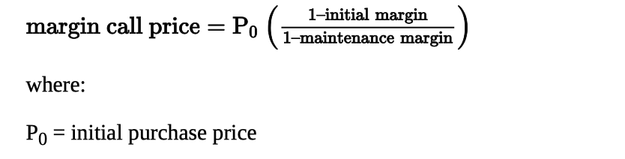

LOS 44.g

Execution instructions specify how to trade. Market orders and limit orders are examples of execution instructions. Validity instructions specify when an order can be filled. Day orders, good til canceled orders, and stop orders are examples of validity instructions. Clearing instructions specify how to settle a trade.

LOS 44.h

A market order is an order to execute the trade immediately at the best possible price. A market order is appropriate when the trader wants to execute a transaction quickly. The disadvantage of a market order is that it may execute at an unfavorable price. A limit order is an order to trade at the best possible price, subject to the price satisfying the limit condition. A limit order avoids price execution uncertainty. The disadvantage of a limit order is that it may not be filled. A buy (sell) order with a limit of $18 will only be executed if the security can be bought (sold) at a price of $18 or less (more).

LOS 44.i

New issues of securities are sold in primary capital markets. Secondary financial markets are where securities trade after their initial issuance. In an underwritten offering, the investment bank guarantees that the issue will be sold at a price that is negotiated between the issuer and bank. In a best efforts offering, the bank acts only as a broker. In a private placement, a firm sells securities directly to qualified investors, without the disclosures of a public offering. A liquid secondary market makes it easier for firms to raise external capital in the primary market, which results in a lower cost of capital for firms.

LOS 44.j

There are three main categories of securities markets: 1. Quote-driven markets: Investors trade with dealers that maintain inventories of securities, currencies, or contracts. 2. Order-driven markets: Order-matching and trade-pricing rules are used to match the orders of buyers and sellers. 3. Brokered markets: Brokers locate a counterparty to take the other side of a buy or sell order. In call markets, securities are only traded at specific times. In continuous markets, trades occur at any time the market is open.

LOS 44.k

A well-functioning financial system has the following characteristics: Complete markets: Savers receive a return, borrowers can obtain capital, hedgers can manage risks, and traders can acquire needed assets. Operational efficiency: Trading costs are low.

Informational efficiency: Prices reflect fundamental information quickly.

Allocational efficiency: Capital is directed to its highest valued use.

LOS 44.l

The objectives of market regulation are to: Protect unsophisticated investors. Establish minimum standards of competency. Help investors to evaluate performance. Prevent insiders from exploiting other investors. Promote common financial reporting requirements so that information gathering is less expensive. Require minimum levels of capital so that market participants will be able to honor their commitments and be more careful about their risks.

LOS 45.a

A security market index represents the performance of an asset class, security market, or segment of a market. The performance of the market or segment over a period of time is represented by the percentage change in (i.e., the return on) the value of the index.

LOS 45.b

A price index uses only the prices of the constituent securities in the return calculation. The rate of return is called a price return. A total return index uses both the price of and the income from the index securities in the return calculation.

LOS 45.c

Decisions that index providers must make when constructing and managing indexes include: The target market the index will measure. Which securities from the target market to include. The appropriate weighting method. How frequently to rebalance the index to its target weights. How frequently to re-examine the selection and weighting of securities.

LOS 45.d

A price-weighted index is the arithmetic mean of the prices of the index securities. The divisor, which is initially equal to the number of securities in the index, must be adjusted for stock splits and changes in the composition of the index over time. An equal-weighted index assigns the same weight to each of its constituent securities. A market capitalization-weighted index gives each constituent security a weight equal to its proportion of the total market value of all securities in the index. Market capitalization can be adjusted for a security’s market float or free float to reflect the fact that not all outstanding shares are available for purchase. A fundamental-weighted index uses weights that are independent of security prices, such as company earnings, revenue, assets, or cash flow.

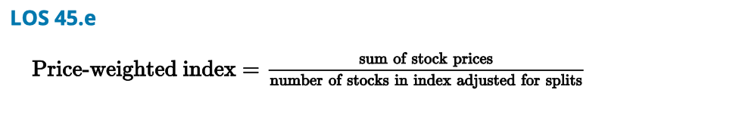

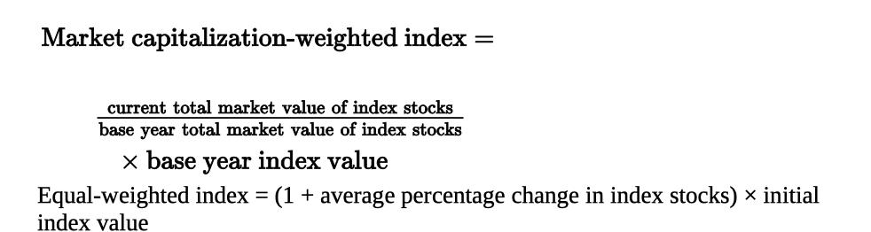

LOS 45.f

Index providers periodically rebalance the weights of the constituent securities. This is most important for equal-weighted indexes.

Reconstitution refers to changing the securities that are included in an index. This is necessary when securities mature or when they no longer have the required characteristics to be included.

LOS 45.g

Indexes are used for the following purposes:

Reflection of market sentiment.

Benchmark of manager performance.

Measure of market return.

Measure of beta and excess return.

Model portfolio for index funds.

LOS 45.h

Broad market equity indexes represent the majority of stocks in a market.

Multi-market equity indexes contain the indexes of several countries. Multi-market equity indexes with fundamental weighting use market capitalization weighting for the securities within a country’s market but then weight the countries within the global index by a fundamental factor.

Sector indexes measure the returns for a sector (e.g., health care) and are useful because some sectors do better than others in certain business cycle phases. These indexes are used to evaluate portfolio managers and as models for sector investment funds.

Style indexes measure the returns to market capitalization and value or growth strategies. Stocks tend to migrate among classifications, which causes style indexes to have higher constituent turnover than broad market indexes.

LOS 45.i

Fixed-income indexes can be classified by issuer, collateral, coupon, maturity, credit risk (e.g., investment grade versus high-yield), and inflation protection. They can be delineated as broad market, sector, style, or other specialized indexes. Indexes exist for various sectors, regions, and levels of development.

The fixed-income security universe is much broader than the equity universe, and fixed- income indexes have higher turnover. Index providers must depend on dealers for fixed- income security prices, and the securities are often illiquid. Fixed-income security indexes vary widely in their numbers of constituent securities and can be difficult and expensive to replicate.

LOS 45.j

Indexes have been developed to represent markets for alternative assets such as commodities, real estate, and hedge funds.

Issues in creating commodity indexes include the weighting method (different indexes can have vastly different commodity weights and resulting risk and return) and the fact that commodity indexes are based on the performance of commodity futures contracts, not the actual commodities, which can result in different performance for a commodity index versus the actual commodity.

Real estate indexes include appraisal indexes, repeat property sales indexes, and indexes of real estate investment trusts.

Because hedge funds report their performance to index providers voluntarily, the performance of different hedge fund indexes can vary substantially and index returns have an upward bias.

LOS 45.k

Security market indexes available from commercial providers represent a variety of asset classes and reflect target markets that can be classified by:

Geographic location, such as country, regional, or global indexes.

Sector or industry, such as indexes of energy producers.

Level of economic development, such as emerging market indexes.

Fundamental factors, such as indexes of value stocks or growth stocks.

Reading 46 Market Efficiency

LOS 46.a

In an informationally efficient capital market, security prices reflect all available information fully, quickly, and rationally. The more efficient a market is, the quicker its reaction will be to new information. Only unexpected information should elicit a response from traders.

If the market is fully efficient, active investment strategies cannot earn positive risk- adjusted returns consistently, and investors should therefore use a passive strategy.

LOS 46.b

An asset’s market value is the price at which it can currently be bought or sold.

An asset’s intrinsic value is the price that investors with full knowledge of the asset’s characteristics would place on the asset.

LOS 46.c

Large numbers of market participants and greater information availability tend to make markets more efficient.

Impediments to arbitrage and short selling and high costs of trading and gathering information tend to make markets less efficient.

LOS 46.d

The weak form of the efficient markets hypothesis (EMH) states that security prices fully reflect all past price and volume information.

The semi-strong form of the EMH states that security prices fully reflect all publicly available information.

The strong form of the EMH states that security prices fully reflect all public and private information.

LOS 46.e

If markets are weak-form efficient, technical analysis does not consistently result in abnormal profits.

If markets are semi-strong form efficient, fundamental analysis does not consistently result in abnormal profits. However, fundamental analysis is necessary if market prices are to be semi-strong form efficient.

If markets are strong-form efficient, active investment management does not consistently result in abnormal profits.

Even if markets are strong-form efficient, portfolio managers can add value by establishing and implementing portfolio risk and return objectives and assisting with portfolio diversification, asset allocation, and tax minimization.

LOS 46.f

A market anomaly is something that deviates from the efficient market hypothesis. Most evidence suggests anomalies are not violations of market efficiency but are due to the methodologies used in anomaly research, such as data mining or failing to adjust adequately for risk.

Anomalies that have been identified in time-series data include calendar anomalies such as the January effect (small firm stock returns are higher at the beginning of January), overreaction anomalies (stock returns subsequently reverse), and momentum anomalies (high short-term returns are followed by continued high returns).

Anomalies that have been identified in cross-sectional data include a size effect (small- cap stocks outperform large-cap stocks) and a value effect (value stocks outperform growth stocks).

Other identified anomalies involve closed-end investment funds selling at a discount to NAV, slow adjustments to earnings surprises, investor overreaction to and long-term underperformance of IPOs, and a relationship between stock returns and prior economic fundamentals.

LOS 46.g

Behavioral finance examines whether investors behave rationally, how investor behavior affects financial markets, and how cognitive biases may result in anomalies. Behavioral finance describes investor irrationality but does not necessarily refute market efficiency as long as investors cannot consistently earn abnormal risk-adjusted returns.

Reading 47 Equity Securities

LOS 47.a

Common shareholders have a residual claim on firm assets and govern the corporation through voting rights. Common shares have variable dividends which the firm is under no legal obligation to pay.

Callable common shares allow the firm the right to repurchase the shares at a pre- specified price. Putable common shares give the shareholder the right to sell the shares back to the firm at a pre-specified price.

Preferred stock typically does not mature, does not have voting rights, and has dividends that are fixed in amount but are not a contractual obligation of the firm.

Cumulative preferred shares require any dividends that were missed in the past (dividends in arrears) to be paid before common shareholders receive any dividends. Participating preferred shares receive extra dividends if firm profits exceed a pre- specified level and a value greater than the par value if the firm is liquidated. Convertible preferred stock can be converted to common stock at a pre-specified conversion ratio.

LOS 47.b

Some companies’ equity shares are divided into different classes, such as Class A and Class B shares. Different classes of common equity may have different voting rights and priority in liquidation.

LOS 47.c

Compared to publicly traded firms, private equity firms have lower reporting costs, greater ability to focus on long-term prospects, and potentially greater return for investors once the firm goes public. However, private equity investments are illiquid, firm financial disclosure may be limited, and corporate governance may be weaker.

LOS 47.d

Investors who buy foreign stock directly on a foreign stock exchange receive a return denominated in a foreign currency, must abide by the foreign stock exchange’s regulations and procedures, and may be faced with less liquidity and less transparency than is available in the investor’s domestic markets. Investors can often avoid these disadvantages by purchasing depository receipts for the foreign stock that trade on their domestic exchange.

Global depository receipts are issued outside the United States and outside the issuer’s home country. American depository receipts are denominated in U.S. dollars and are traded on U.S. exchanges.

Global registered shares are common shares of a firm that trade in different currencies on stock exchanges throughout the world.

Baskets of listed depository receipts are exchange-traded funds that invest in depository receipts.

LOS 47.e

Equity investor returns consist of dividends, capital gains or losses from changes in share prices, and any foreign exchange gains or losses on shares traded in a foreign currency. Compounding of reinvested dividends has been an important part of an equity investor’s long-term return.

Preferred stock is less risky than common stock because preferred stock pays a known, fixed dividend to investors; preferred stockholders must receive dividends before common stock dividends can be paid; and preferred stockholders have a claim equal to par value if the firm is liquidated. Putable shares are the least risky and callable shares are the most risky. Cumulative preferred shares are less risky than non-cumulative preferred shares, as any dividends missed must be paid before a common stock dividend can be paid.

LOS 47.f

Equity securities provide funds to the firm to buy productive assets, to buy other companies, or to offer to employees as compensation. Equity securities provide liquidity that may be important when the firm must raise additional funds.

LOS 47.g

The book value of equity is the difference between the financial statement value of the firm’s assets and liabilities. Positive retained earnings increase the book value of equity. Book values reflect the firm’s past operating and financing choices.

The market value of equity is the share price multiplied by the number of shares outstanding. Market value reflects investors’ expectations about the timing, amount, and risk of the firm’s future cash flows.

LOS 47.h

The accounting return on equity (ROE) is calculated as the firm’s net income divided by the book value of common equity. ROE measures whether management is generating a return on common equity but is affected by the firm’s accounting methods.

The firm’s cost of equity is the minimum rate of return that investors in the firm’s equity require. Investors’ required rates of return are reflected in the market prices of the firm’s shares.

Reading 48 Industry Analysis

LOS 48.a

Industry analysis is necessary for understanding a company’s business environment before engaging in analysis of the company. The industry environment can provide information about the firm’s potential growth, competition, risks, appropriate debt levels, and credit risk.

Industry valuation can be used in an active management strategy to determine which industries to overweight or underweight in a portfolio.

Industry representation is often a component in a performance attribution analysis of a portfolio’s return.

LOS 48.b

Firms can be grouped into industries according to their products and services or business cycle sensitivity, or through statistical methods that group firms with high historical correlation in returns.

Industry classification systems from commercial providers include the Global Industry Classification Standard (Standard & Poor’s and MSCI Barra), Russell Global Sectors, and the Industry Classification Benchmark (Dow Jones and FTSE).

Industry classification systems developed by government agencies include the International Standard Industrial Classification (ISIC), the North American Industry Classification System (NAICS), and systems designed for the European Union and Australia/New Zealand.

LOS 48.c

A cyclical firm has earnings that are highly dependent on the business cycle. A non- cyclical firm has earnings that are less dependent on the business cycle. Industries can also be classified as cyclical or non-cyclical. Non-cyclical industries or firms can be classified as defensive (demand for the product tends not to fluctuate with the business cycle) or growth (demand is so strong that it is largely unaffected by the business cycle).

Limitations of descriptors such as growth, defensive, and cyclical include the facts that cyclical industries often include growth firms; even non-cyclical industries can be affected by severe recessions; defensive industries are not always safe investments; business cycle timing differs across countries and regions; and the classification of firms is somewhat arbitrary.

LOS 48.d

A peer group should consist of companies with similar business activities, demand drivers, cost structure drivers, and availability of capital. To form a peer group, the analyst will often start by identifying companies in the same industry, but the analyst should use other information to verify that the firms in an industry are comparable.

LOS 48.e

A thorough industry analysis should: Evaluate the relationships between macroeconomic variables and industry trends. Estimate industry variables using different approaches and scenarios. Check estimates against those from other analysts. Compare the valuation for different industries. Compare the valuation for industries across time to determine risk and rotation strategies. Analyze industry prospects based on strategic groups. Classify industries by their life-cycle stage. Position the industry on the experience curve. Consider demographic, macroeconomic, governmental, social, and technological influences. Examine the forces that determine industry competition.

LOS 48.f

Strategic analysis of an industry involves analyzing the competitive forces that determine the possibility of economic profits. Porter’s five forces that determine industry competition are: 1. Rivalry among existing competitors. 2. Threat of entry. 3. Threat of substitutes. 4. Power of buyers. 5. Power of suppliers.

LOS 48.g

High barriers to entry prevent new competitors from taking away market share, but they do not guarantee pricing power or high return on capital, especially if the products are undifferentiated or barriers to exit result in overcapacity. Barriers to entry may change over time. While market fragmentation usually results in strong competition and low return on capital, high industry concentration may not guarantee pricing power. If industry products are undifferentiated, consumers will switch to the cheapest producer. Overcapacity may result in price wars. Capacity is fixed in the short run and variable in the long run. Undercapacity typically results in pricing power. Producers may overinvest in new capacity, especially in cyclical industries or if the capacity is physical and specialized. Non-physical capacity comes into production and can be reallocated more quickly than physical capacity. Highly variable market shares indicate a highly competitive industry. Stable market shares suggest less intense competition. High switching costs contribute to market share stability.

LOS 48.h

Phases of the industry life-cycle model are the embryonic, growth, shakeout, maturity, and decline stages.

Embryonic stage: Slow growth; high prices; large investment required; high risk of failure.

Growth stage: Rapid growth; little competition; falling prices; increasing profitability.

Shakeout stage: Slowing growth; intense competition; industry overcapacity; declining profitability; cost cutting; increased failures.

Mature stage: Slow growth; consolidation; high barriers to entry; stable pricing; superior firms gain market share.

Decline stage: Negative growth; declining prices; consolidation.

A limitation of life-cycle analysis is that life-cycle stages may not be as long or short as anticipated or might be skipped altogether due to technological change, government regulation, societal change, or demographics. Firms in the same life-cycle stage will experience dissimilar growth and profits due to their competitive positions.

LOS 48.i

The elements of an industry strategic analysis are the major firms, barriers to entry, industry concentration, influence of industry capacity on pricing, industry stability, life cycle, competition, demographic influences, government influence, social influence, technological influence, and whether the industry is growth, defensive, or cyclical.

LOS 48.j

Macroeconomic influences on industries include long-term trends in factors such as GDP growth, interest rates, and inflation, as well as structural factors such as the education level of the workforce.

Demographic influences include the size and age distribution of the population.

Government factors include tax rates, regulations, empowerment of self-regulatory organizations, and government purchases of goods and services.

Social influences relate to how people interact and conduct their lives.

Technology can dramatically change an industry through the introduction of new or improved products.

LOS 48.k

Company analysis should include an overview of the firm, industry characteristics, and analysis of product demand, product costs, the pricing environment, the firm’s financial ratios, and projected financial statements and firm valuation. The analysis should describe the company’s competitive strategy.

Companies can employ a cost leadership (low-cost) strategy or a product or service differentiation strategy. A cost leadership firm seeks to have the lowest costs of production in its industry, offer the lowest prices, and generate enough volume to make a superior return. A differentiating firm’s products and services should be distinctive in terms of type, quality, or delivery.

Reading 49 EQUITY VALUATION: CONCEPTS AND BASIC TOOLS

LOS 49.a

An asset is fairly valued if the market price is equal to its estimated intrinsic value, undervalued if the market price is less than its estimated value, and overvalued if the market price is greater than the estimated value.

For security valuation to be profitable, the security must be mispriced now and price must converge to intrinsic value over the investment horizon.

Securities that are followed by many investors are more likely to be fairly valued than securities that are neglected by analysts.

LOS 49.b

Discounted cash flow models estimate the present value of cash distributed to shareholders (dividend discount models) or the present value of cash available to shareholders after meeting capital expenditures and working capital expenses (free cash flow to equity models).

Multiplier models compare the stock price to earnings, sales, book value, or cash flow. Alternatively, enterprise value is compared to sales or EBITDA.

Asset-based models define a stock’s value as the firm’s total asset value minus liabilities and preferred stock, on a per-share basis.

LOS 49.c

Regular cash dividends are paid at set intervals. A special dividend is a one-time cash payment to shareholders.

Stock dividends are additional shares of stock. Stock splits divide each existing share into multiple shares. In either case, the value of each share will decrease because the total value of outstanding shares is unchanged. The portion of the company owned by each shareholder is also unchanged.

In a reverse stock split, the number of shares owned by each shareholder is decreased, so total shares outstanding are decreased and the value of a single share is increased.

A share repurchase is a purchase by the company of its outstanding shares. Share repurchases are an alternative to cash dividends as a way to distribute cash to shareholders.

LOS 49.d

Dividend payment chronology:

Declaration date: The date the board of directors approves payment of the dividend.

Ex-dividend date: The first day a share of stock trades without the dividend, one or two business days before the holder-of-record date. On the ex-dividend date, the value of each share decreases by the amount of the dividend.

Holder-of-record date: The date on which share owners who will receive the dividend are identified.

Payment date. The date the dividend checks are sent to, or payment is transferred to, shareholders.

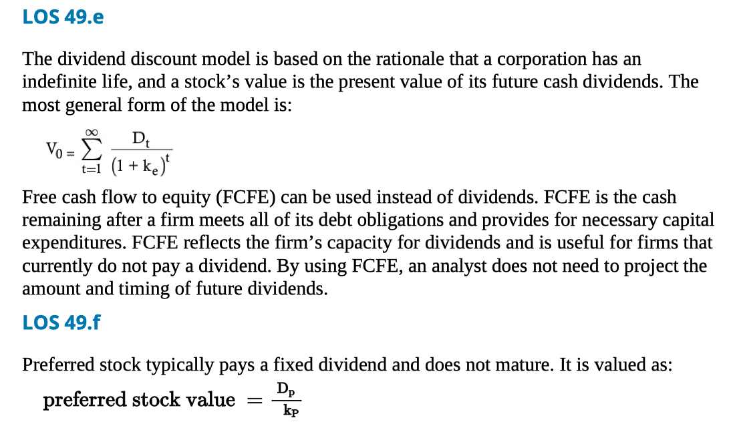

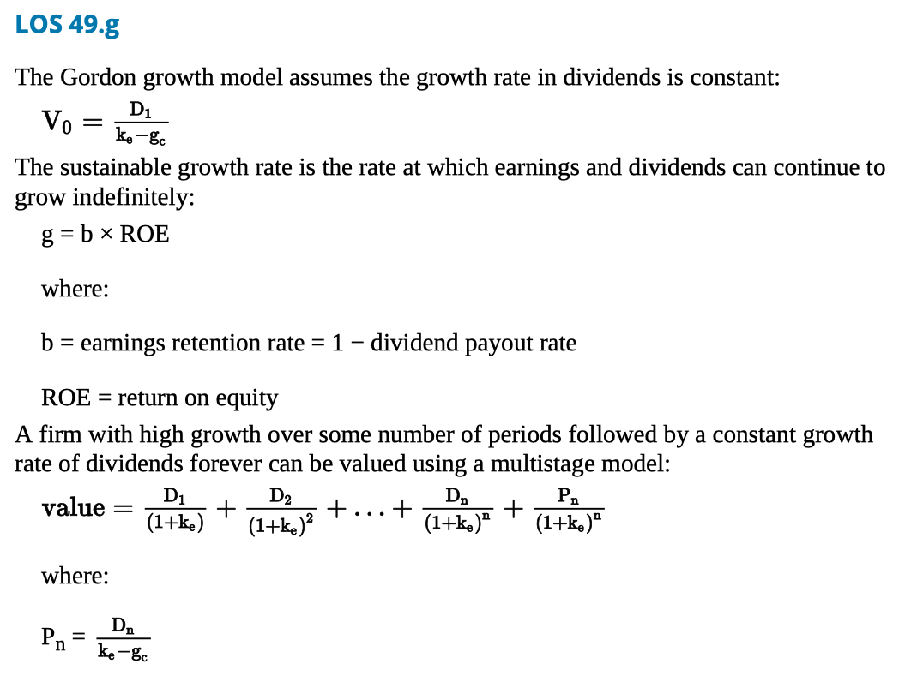

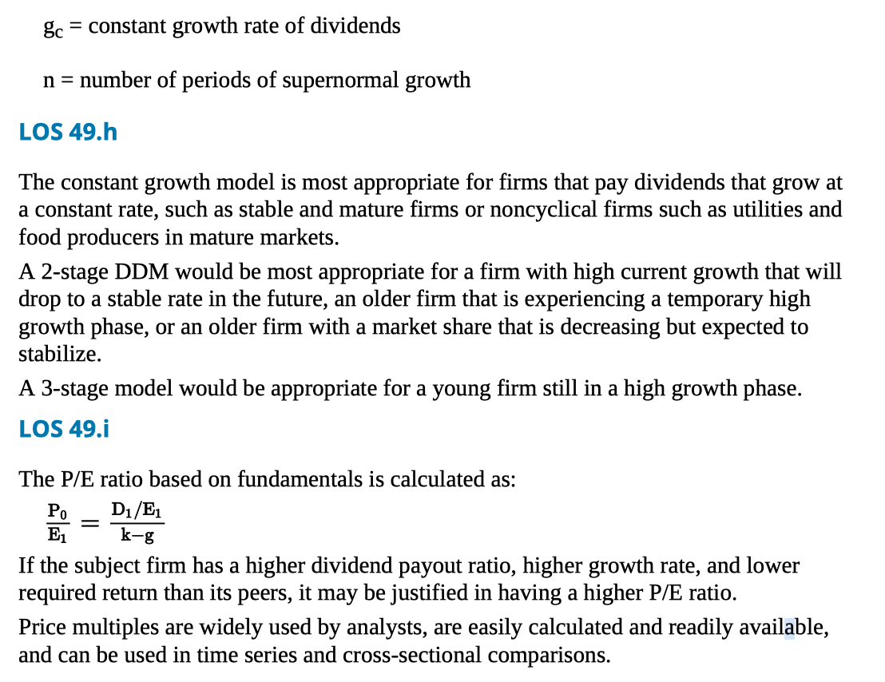

LOS 49.j

The price-earnings (P/E) ratio is a firm’s stock price divided by earnings per share.

The price-sales (P/S) ratio is a firm’s stock price divided by sales per share.

The price-book value (P/B) ratio is a firm’s stock price divided by book value per share.

The price-cash flow (P/CF) ratio is a firm’s stock price divided by cash flow per share. Cash flow may be defined as operating cash flow or free cash flow.

LOS 49.k

Enterprise value (EV) measures total company value:

EV = market value of common and preferred stock + market value of debt − cash and short-term investments

EBITDA is frequently used as the denominator in EV multiples because EV represents total company value, and EBITDA represents earnings available to all investors.

LOS 49.l

Asset-based models value equity as the market or fair value of assets minus liabilities. These models are most appropriate when a firm’s assets are largely tangible and have fair values that can be established easily.

LOS 49.m

